**FUNDAMENTALS OF DATA ANALYTICS WITH TABLEAU**

**PROJECT TITLE**

**ANALYSING HOUSING PRICES IN METROPOLITAN AREAS OF INDIA**

**NAAN MUDHALVAN PROJECT ID:**

**NM2023TMID27902**

**TEAM MEMBERS**

1. **P.VEERAPRABAKARAR [TEAM LEADER]**
2. **P.PRASATH**
3. **A.MANOJ KUMAR**
4. **M.THANGARAJA**



**PG AND RESEARCH DEPARTMENT OF PHYSICS**

**RAJA DORAISINGAM GOVERNMENT ARTS COLLEGE**

**SIVAGANGAI-630561**

**PG AND RESEARCH DEPARTMENT OF PHYSICS**

**RAJA DORAISINGAM GOVERNMENT ARTS COLLEGE**

**SIVAGANGAI-630561**

**Analysing Housing Prices in Metropolitan Areas of India**

# INTRODUCTION:

## Description of Project:

House price prediction in a metropolitan city in India is a valuable solution for potential home buyers, real estate agents, and investors. By leveraging historical sales data, property details, and location-specific information, a predictive model can accurately estimate house prices. The model's scalability, real-time updates, user-friendly interface, and transparency ensure it meets the needs of stakeholders. Integration capability, data privacy, and cost-effectiveness are also important considerations. By addressing these requirements, the prediction model provides reliable insights, empowering stakeholders to make informed decisions in the fast-paced real estate market.

## Uses:

Its use to analyses the details of housing prices in metropolitan areas of India

## PROBLEM DEFINITION & DESIGN THINKING:

## Empathy map:

* First we make a empathy map for a group idea .To create a empathy map go to mural web site and logic with email account and search the templates that you wanted to create.

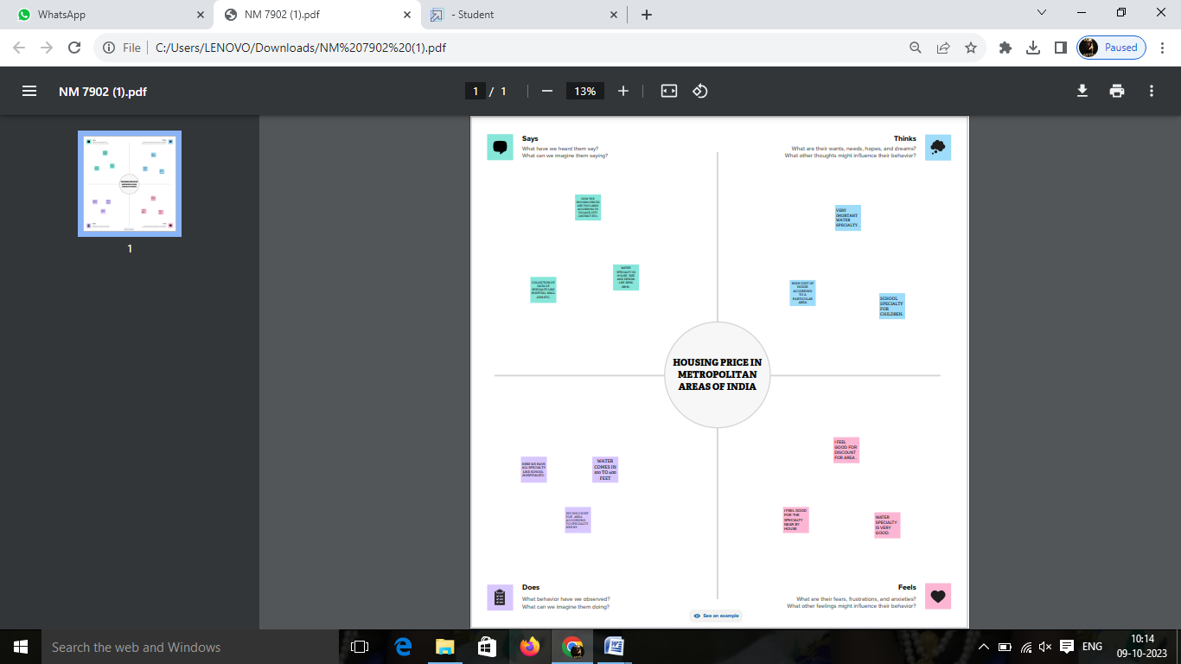

## BRAINSTORMING MAP:

* Then make a brainstorm map with mural website. I brainstorm we discussed the define problem and understand the problem. First we have defined what are the problems and types in the question box. Then it is a group idea and write in the box as person1, person2 and person 3. Now three person give different idea for the same problem.
* Take best three idea and type in last box.

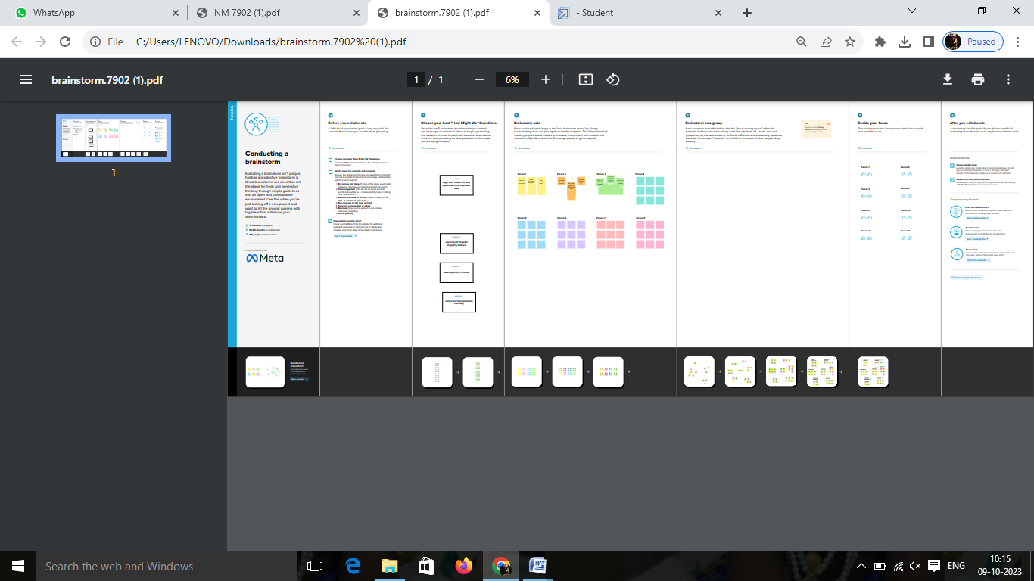

# PROCEDURE FOR TABLEAU PROJECT:

* Before opening the tableau desktop we had download the dataset for your project.
* after download the dataset we open the tableau desktop
* After opening the selected link connect to data, select the “more” option and select the dataset.
* It opens in the data source, now we arranged the data and select the “extract” option for the better performance for you analysis. We have arranged our project in the order airports data is first, air route as second, airlines and airplanes are joined together with air routes. Now we have switched to extract mode and we have created 6000+ row that we need. After we saved the data.

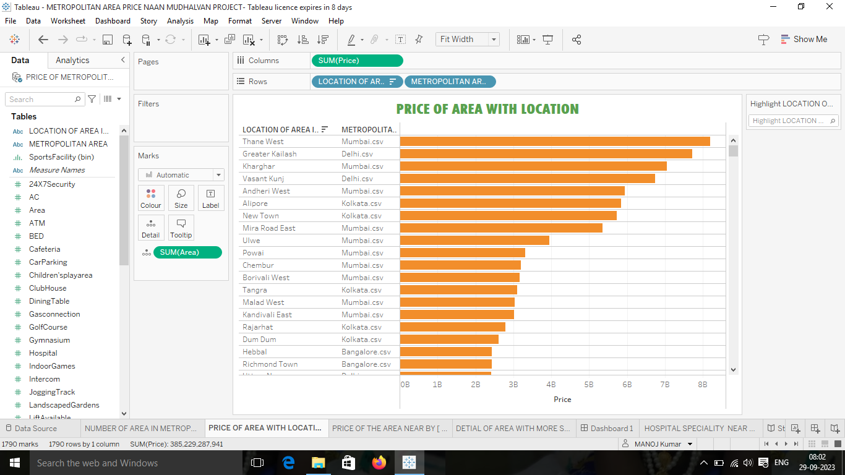

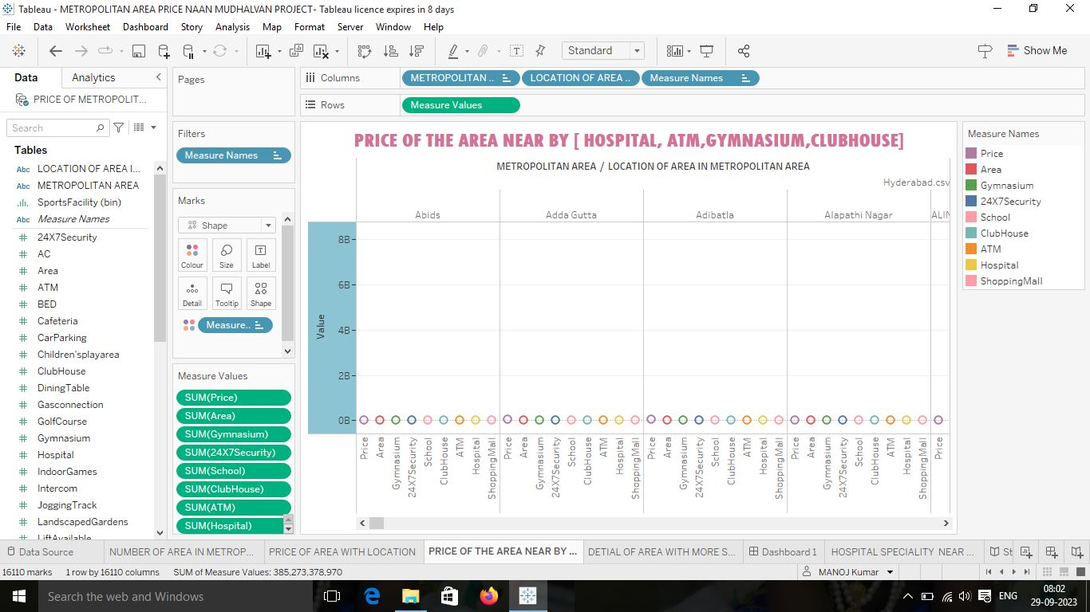

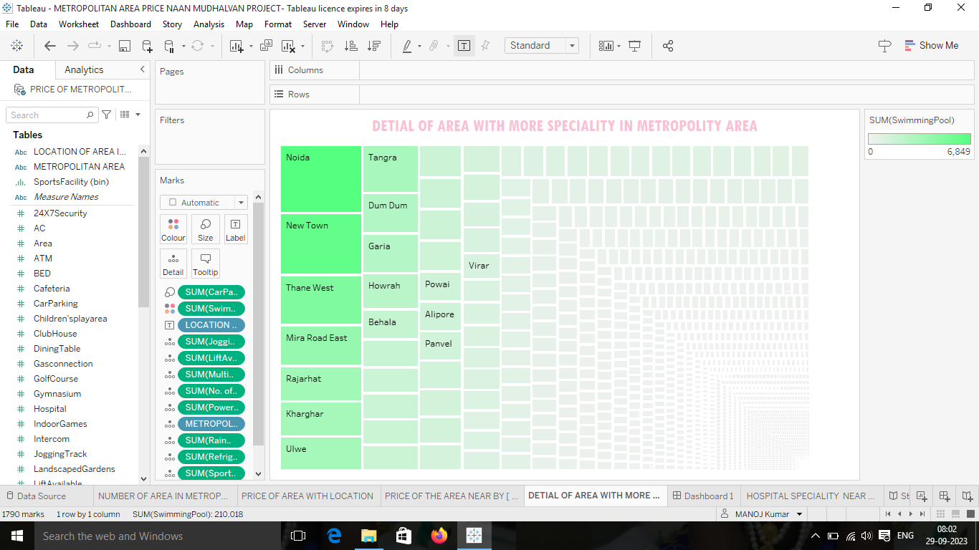

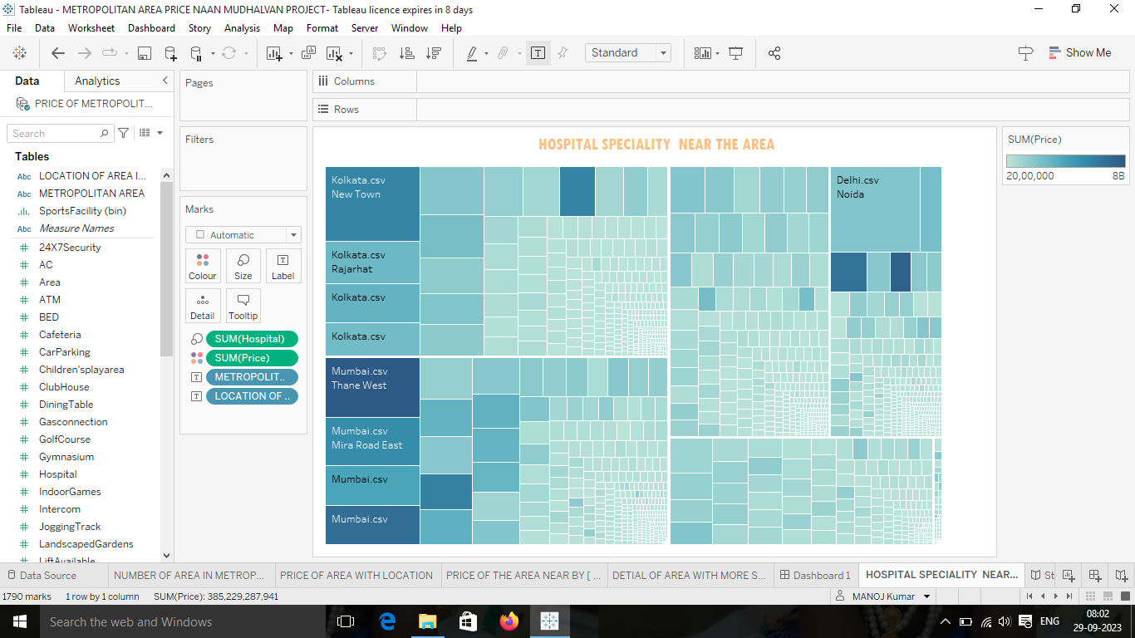

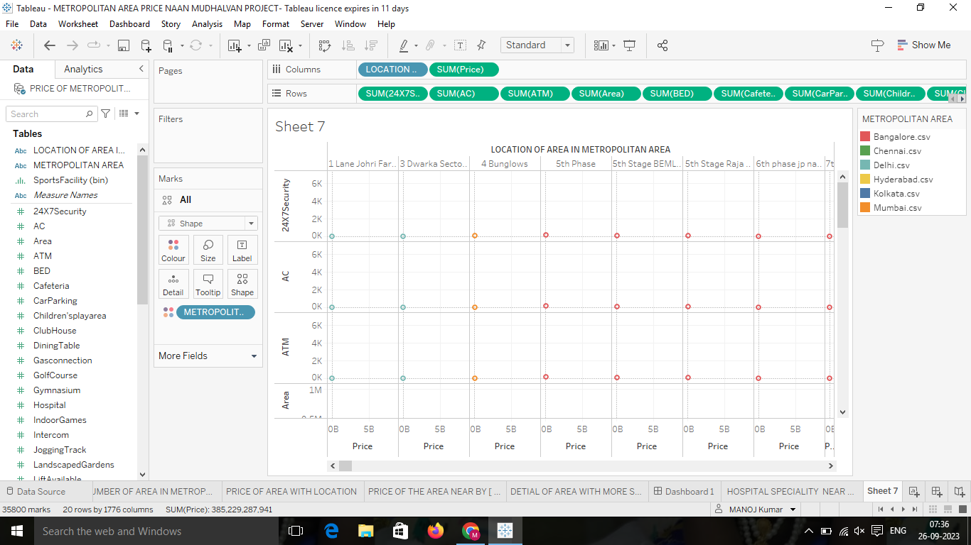

* After finishing the analysis data, add a dashboard.
* In the dashboard we can combine more sheets in single dashboard. The dashboard contains the combine of sheet that we created.

# RESULT:

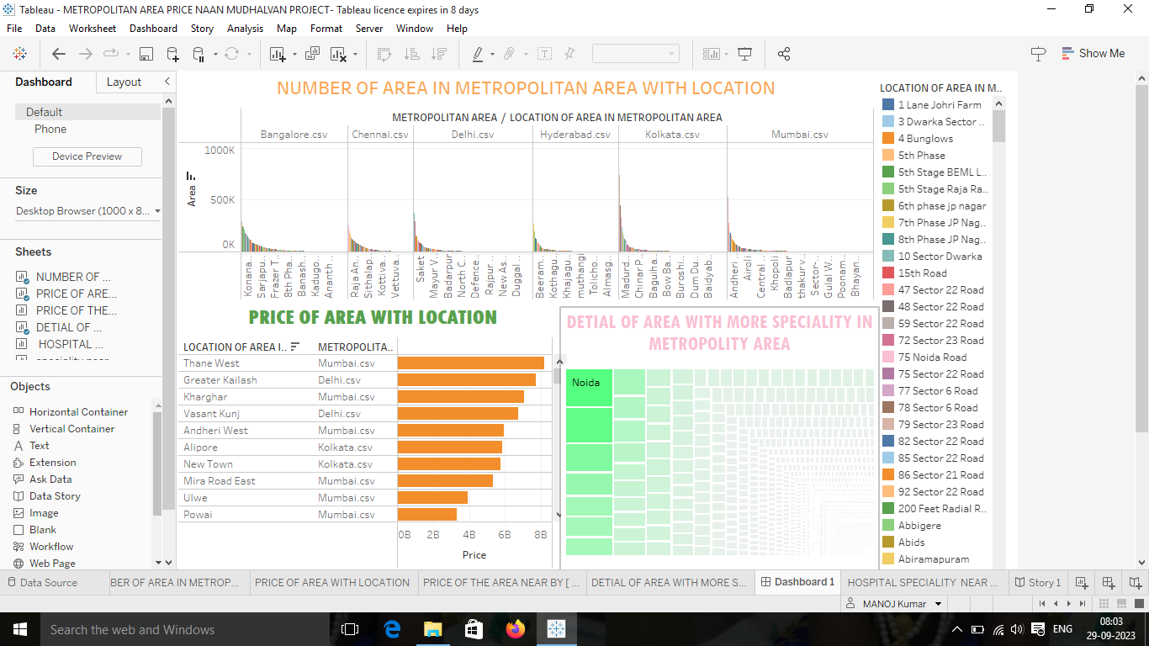

* We created a story in the tableau desktop.

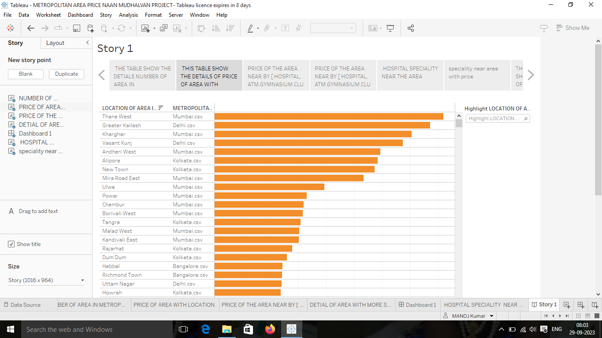

* Sign into the tableau account.
* Publish the workbook in the tableau cloud.
* Upload the project in the github.

## ADVANTAGES:

The result of the I’m, Pesaro and Shin panel unit root test is presented in Table 1. The consistently high probabilities of the relative house prices indicate that the series is consistently non-stationary and therefore diverges indefinitely in the long-run. The lack of convergence of the relative house prices simply implies that separate metropolitan cities in India function as separate housing markets in their respective localities. In other words, the Law of One Price (LOOP) does not hold in Indian housing market case.

## DISADVANTAGES:

* It doesn't predict future prices of the houses mentioned by the customer.

# Application:

* This visualizing and analyzing is very easier to analyses the data of the price of metropolitan area in India and it helps in making business decision.

# Conclusion:

The tableau desktop is very useful to analyses the large number of data in one screen. We have learn how to analyses the data, how visualizing the data and how to create a dashboard and story.

Our project is unlocking insight into the global air transportation network and has more 5 sheets, 1dashboards and 1 story.